Step 3 – Restated Statements Commentary
After getting full marks for the original entering of the financial statements, and how much I love spreadsheets. I certainly put a lot of pressure on myself to succeed in this step of restating the statements. I am often very critical of myself and find it hard to make decisions as I constantly question and self-doubt my thoughts. However, I will do my best to classify the financial and as long as they balance, I’ll be happy to know I was on the right path in one way or another.
Statement of Equity and Changes
I found the SOCIE relatively easy to restate, and I had no major issues. However, I did have some queries and doubts as to whether I was allocating the right items to operating/financial. I asked the question on my blog here https://cherieaccounting.school.blog/2019/08/30/help-please/
Balance Sheet
I also found the balance sheet relatively easy. After completing the SOCIE I sort of got into a rhythm. Although it did take me some time, as my firm has a lot of items listed compared to other peers’ financial statements. The main query I had was about how my firm listed out their cash allocating. I wasn’t sure whether I need to list in separately like they did on the balance sheet. However, after watch the restating video from Maria, I took the option of just using the total figure and allocating it the same way as the video advised to do so. I felt this worked out the best possible way.
Income Statement
During ASS#1 Maria advised we needed to ensure we had the finance income or interest income found and added to our original spreadsheet. One thing I noticed here, was that interest income was already listed in my income statement under operating income. I wasn’t sure if there was another figure I should be looking for or is this it? My statements are consolidated statements, maybe that why? I left my spreadsheet layout the same as it was originally entered.
As soon as I went to classify my income statement into O & F, I now remember how much of a pain in my bum the statement was to enter. It took a lot of my time calculating the totals of operating in 2015/2016 due to the statements being divided into Operating Income for both Vehicles/Services and Financial services. My income statement is also lengthy compared to other peers I had reviewed. I am simply dreading this process; I just hope I classify it correctly. Cue self-doubt!
I posted to my blog for some help around classifying some items due to some words in the headings, you can view it here https://cherieaccounting.school.blog/2019/09/10/is-anyone-out-there-having-this-issue/. In the end I was happy with the overall decisions I made to the allocated items.
The ‘Share of Income in Joint Adventures’ in 2015/2016 it was operational, however in 2017/2018 it was included in the total financial items of the statement, therefore I included it in financial for these two years as I felt it made the most sense. In these years they may have been a reason/explanation for it being so.
The titles for though one title was ‘Other Operating Income/Expenses” and another was simply ‘Other Income/Expenses’ (negated the operating or financial title), I decided to include this on the same line for each year as I classified both items as an ‘operating’ income or expenses, it was just listed differently for the 2015/2016 to the 2017/2018 period. I am hoping this won’t make much of a difference as they are essentially one of the same
There was selling and administrative costs listed twice for 2015/2016 so I decided to leave one in operating and other as a finance expense due to it being listed in the Financial sector of that particular years annual statement
When it came to checking OI + NFE = CI – my 2018/2017 matched however my 2016/2015 did not and were out by about 2000 each. I found the figures were my interest suplus’, it took me some time to realise, but this figure were actually a total on my income statement and not an item, so I simply had to remove this from the restate statement and it all balances out.
My restated income statement is all completed, the checks match that of OI + NFE = Original CI and O CI +F CI = SOCIE CI. I feel this task assisted in understanding the individual items on each financial statement. I had a few queries and doubt as listed above, but all in all I learnt a lot and feel I have done a good job. This was certainly the more challenging statement to restate.

Step 4 – Peer Feedback
As mentioned in ASS#1 I found not having Facebook hard again for this assessment. I feel Facebook in terms of instant viewing/messaging would have been beneficial in reaching out to others for help. Especially when it came to classify certain items, I felt it was easier just to go with my gut instinct. I felt the blogs are really only helpful if everyone actually checks for blog posts or posts themselves. Nonetheless, I did reach out for help on my blog, and on one instant was able to gain some help to a query which was greatly appreciated.
Here is some blog posts, comments I received and also provided throughout this tasks.
https://cherieaccounting.school.blog/2019/08/30/help-please/
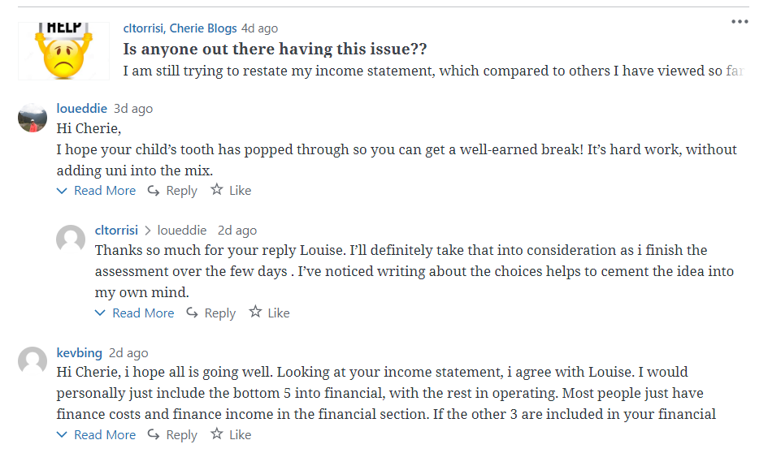
https://cherieaccounting.school.blog/2019/09/10/is-anyone-out-there-having-this-issue/

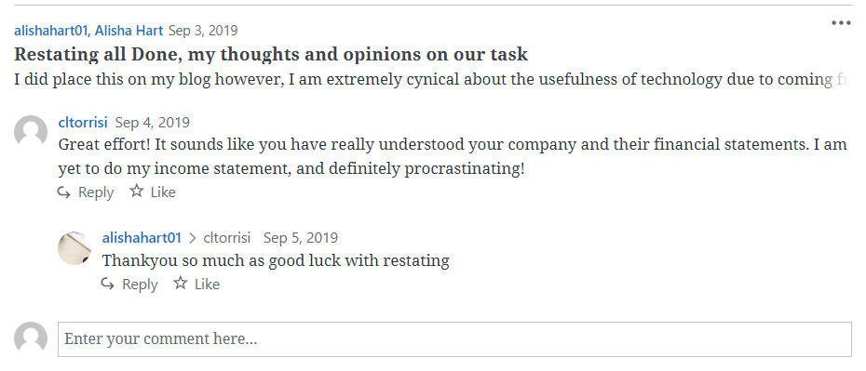

I chose to give feedback to the following: Ashlea King, Jessica Bishop and Kevin Bingham
PEER FEEDBACK SHEET: ASS#2 Step 4
Feedback From: Cherie Torrisi
Feedback To: Kevin Bingham.

 | My Comments
Step 3 | Restated SOCIE  - Your closing balances matches the original financial statements – CORRECT – although you have linked your totals rather than using the sum feature to ensure you have bought all the items over into the restating sheet  Restated Balance Sheet  - OA + FA = matches total assets in original financials CORRECT – you didn’t necessarily have a total assets in original financials, however when I added them together without the liabilities, they matched.  - OL + FL = matches total liabilities in original financial CORRECT - you didn’t necessarily have a total liabilities as a heading in original financials, however when I added them together they matched.  - EQUITY MATCHES = CORRECT  - NFA-EQUITY=NOA ---- CORRECT in your case you ended up having NFA instead of NFO, so I took your NFA from you Equity and it matched your NOA  Income Statement  - Unfortunately I cannot give the best feedback for this section as I am still working on my income statement myself. However, judging from the quality of your spreadsheet, I think it safe to assume it would be correct  Commentary  - You provided good commentary on your restating experience.  Your spreadsheet is easy to follow, set out well, and formatting is on point. Great job
Restated Statement of Changes in Equity
Balance Sheet
Income Statement
Commentary and discussion with others

(Note: You may wish to give some comments
on their Excel spreadsheet)
Step 4  Individual feedback with other students | Not Provided
Overall ASS#2 Steps 3 & 4 | Overall you have produced a strong restated spreadsheet, with commentary to match to level of work you put in. Great effort!

PEER FEEDBACK SHEET: ASS#2 Step 4
Feedback From: Cherie-lee Torrisi
Feedback To: ASHLEA KING

 | My Comments
Step 3 | Restated SOCIE  - Your closing balance is linked to the original financial whereas I believe the sum feature is meant to be used to ensure it matches from the linking/restating  Restated Balance Sheet  - Your total equity figure is linked instead of the using the sum feature. Although the items were not changed, I believe we were still meant to use the sum feature for all total to ensure we haven’t missed any items  Income Statement  - Check: OI+NFE = CI in original financial - CORRECT  Commentary  - You briefly explained that you found restating to be harder than anticipated. I think it would be good if you could elaborate as to what was hard and what wasn’t. Why you may have chosen certain items as financial/operating  Your spreadsheet could do with some minor formatting to assist in following along with your work. Blue/White rows plus some borders for totals in your SOCIE and Balance sheet (similar to your income statement).
Restated Statement of Changes in Equity
Balance Sheet
Income Statement
Commentary and discussion with others

(Note: You may wish to give some comments
on their Excel spreadsheet)
Step 4  Individual feedback with other students | Not Provided
Overall ASS#2 Steps 3 & 4 | Overall you have provided a good start to your assignment. I would recommend some minor format changes along with more commentary in your word document would help to strengthen your overall spreadsheet and assessment.  Great effort!

PEER FEEDBACK SHEET: ASS#2 Step 4
Feedback From: Cherie-lee Torrisi
Feedback To: JESSICA BISHOP

 | My Comments
Step 3 | Restated SOCIE  - Your closing balances matches the original financial statements - CORRECT  Restated Balance Sheet  - OA + FA = matches total assets in original financials CORRECT  - OL + FL = matches total liabilities in original financial CORRECT  - EQUITY MATCHES = CORRECT  - NFO+EQUITY=NOA ---- I couldn’t get this correct on your statement. It may be worth double checking Maria’s video on the checks part of this  Income Statement  - Unfortunately I cannot give the best feedback for this section as I am still working on my income statement myself. I see you noted that you have not been able to get it to balance. I hope others may be able to assist you here  Commentary  - Your commentary is brief, however it does state what you found challenging and what you didn’t. It may help to elaborate here slightly  Your spreadsheet could do with some minor formatting to assist visually (blue and white rows), but otherwise this is not a major issue. You posted regularly on your blog about your restating journey.
Restated Statement of Changes in Equity
Balance Sheet
Income Statement
Commentary and discussion with others

(Note: You may wish to give some comments
on their Excel spreadsheet)
Step 4  Individual feedback with other students | I have viewed your feedback and you offer valuable feedback, which I have also viewed firsthand when you reviewed my own assessment. Thank you

I received the following feedback

PEER FEEDBACK SHEET: ASS#2 Step 4
Feedback From: Sammy-Jo Bull
Feedback To: Cherie-lee Torrisi .

 | My Comments
Step 3 | Your spreadsheet is spread out and formatted well, its clear you have been using the formula function of excel. Your opening and closing balances are all equal, as well as all your other amounts within your spreadsheet. It is also clear you have linked the numbers in your original financial statement to your restated financial statement instead of writing them out again. You have included working out with the allocation of cash to O to F. as well as you have marked on your financial statement what items are operational and financial. Your income and balance sheet also have all the correct subheadings and you have listed everything correctly to mr  Commentary and discussion with others N/A
Restated Statement of Changes in Equity
Balance Sheet
Income Statement
Commentary and discussion with others

(Note: You may wish to give some comments
on their Excel spreadsheet)
Step 4  Individual feedback with other students | N/A
Overall ASS#2 Steps 3 & 4 | I can’t see anywhere that needs improvement as it looks pretty much perfect to me. Apart from the uncompleted section. You have produced a good spreadsheet. You just may want to add in if you have had any feedback with other peers. But apart from that well done!!

PEER FEEDBACK SHEET: ASS#2 Step 4
Feedback From: Kevin Bingham
Feedback To: Cherie-Lee Torrisi .

 | My Comments
Step 3 | Restated Statement of Changes in Equity  Everything looks neat and tidy, formatting and linking look good and balance check out with the balance sheet  Balance Sheet  Cherie has one of the biggest balance sheets I have seen, with plenty of items to cover. The balance sheet looks visually good the formatting is in fine shape. The only query I have is having current and non-current liabilities in financial, unless Cherie has seen something in her company notes to have them there.  Income Statement  Not completed at this time.  Commentary and discussion with others  Cherie had some understandable concerns with her income statement. She posted a great plea for help on her blog, which I was happy to look at. As well as having a lot of items to cover, which was generally more than others, the confusion comes with a list of a few items under financial in her original statement. Some of which could on face value come under operating. I commented on her Blog below with my own thoughts’  Hi Cherie, i hope all is going well. Looking at your income statement, i agree with Louise. I would personally just include the bottom 5 into financial, with the rest in operating. Most people just have finance costs and finance income in the financial section. If the other 3 are included in your financial costs in the original statement, then i would go with them also. Other income and expenses would be operational. My only concern is that you have joint ventures and associates in both sections. Maria did mention in her video, they could be either, so maybe that is the case.  Good Luck  Kevin Bingham.
Restated Statement of Changes in Equity
Balance Sheet
Income Statement
Commentary and discussion with others

(Note: You may wish to give some comments
on their Excel spreadsheet)
Step 4  Individual feedback with other students | Not Available at this time.
Overall ASS#2 Steps 3 & 4 | Overall Cherie has done well with her spreadsheet so far, under trying circumstances. She has gone about it in the right way, by also asking for advice on her blog. She has a big job with Scania as her company, but I am sure Cherie will handle all the rest of her assignments well.

