Step 7 – Products, Variable Costs, Contribution Margin & Constraints
7.1- Product & Services
As continually stated by Scania, they are driving the shift towards a more sustainable transport future. Their products speak volumes of this statement, and I have been intrigued by the business throughout this assessment. Scania understand that there is only so much that producing and selling trucks can achieve in the transport industry. They have branched out and offer many different service options: driving training, finance and insurance, flexible maintenance plans and workshop service departments throughout the world.
Finding any sale prices on Scania’s website was a more of a hassle than it needed to be. I tried translating the Swedish webpage so I could get the correct currency, only to not be able to get truck or engine prices unless I contacted a dealer and I wasn’t going to spend that much time. My figures below will be an estimate.
G500 PRIME MOVER
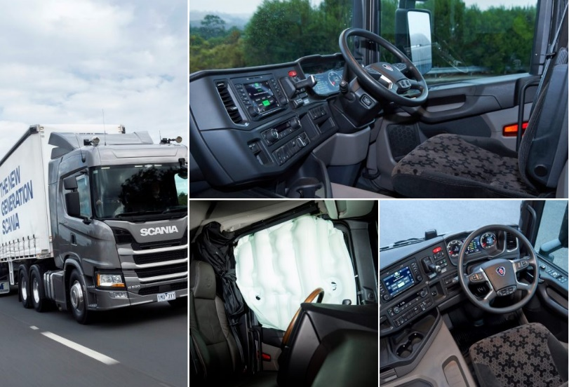
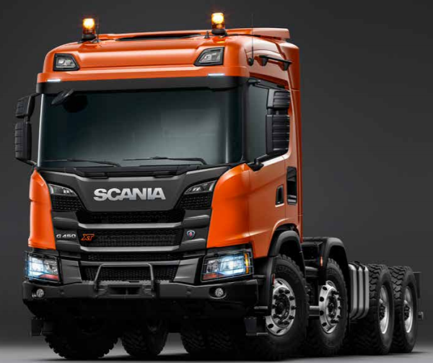
1) The first product I chose was the Scania G500 Prime Mover truck. According to Scania this truck is the world’s safest truck that has rollover curtain airbags that no other manufacturer is yet to offer. This truck is apart of the new generation trucker rollout by Scania and aims to reduce carbon footprint. Retails for SEK 1,942,249 ($291500). There are a number of different truck variants in this range of prime movers, so although they may sell well, they aren’t mass produced due to cost of materials and labour in making such a large vehicle that has a restricted consumer market. I have set my variable costs to be at 70%.
Variable Cost = Sale Price x 70%  = 1,942,249 x 70%  = 1,359,574.3 | Contribution Margin = Sale Price – Variable Cost  = 1,942,249 – 1,359,574.3  = SEK 582,674.7  CM Ratio = 30%

WORKSHOP SERVICES

2) Workshop services is provided throughout the world to service the Scania products. I believe this is a crucial decision, as the company can maintain their high reputation for their vehicles and to continue to use the spare parts they produce, which in return increases the businesses overall income. I have estimated a service cost to be approx. SEK 8328 ($1250) and variable costs to be 50% due to the many varying factors. I don’t believe there would be many variable costs, and this would also depend on the service of the vehicle or whether there were any repairs to be conducted.
Variable Cost = Sale Price x 50%  = 8328 x 50%  = 4164 | Contribution Margin = Sale Price – Variable Cost  = 8328 - 4164  = 4164  CM Ratio = 50%
ECOLUTION BY SCANIA

3) Ecolution is a service provided by Scania to maximise fuel consumption and CO2 emissions. It is designed around the specific operations of the particular customer and the truck. It analyses your transport, load weight, the roads being driven on and the drivers themselves. Not only benefiting the business financially but also our environment. There is also an interesting article about the product being trialled by Australian logistics company VISY. Whilst it maybe a hefty outlay initially, there is great financial gains reported by the businesses trialling Ecolution and therefore a continual market for Scania. I am unsure of how this program is paid for whether an upfront cost or a pay by the month or annual fee. For the purpose of this assessment I am going to assume an annual fee of SEK 40,000 ($6000) and low variable costs of 30% as I believe the main costs involve would be predominately wages for the staff analysing and supporting the program, I also don’t believe there would be a high demand for this, at least not for now.
Variable Cost = Sale Price x 30%  = 40000 x 30%  = 12000 | Contribution Margin = Sale Price – Variable Cost  = 40000 - 12000  = 28000  CM Ratio = 70%
7.2 - Discuss Contribution Margin
 | G500 Prime Mover | Workshop Service | Ecolution
Sales Price | SEK 1,942,249 | SEK 8,328 | SEK 40,000
Variables Costs | SEK 1,359,574.3 | SEK 4,164 | SEK 12,000
Contribution Margin | SEK 582,674.1 | SEK 4,164 | SEK 28,000
Margin Ratio % | 30% | 50% | 70%

I have listed three completely different market opportunities for Scania which does make it hard to compare however, this is what the business does so well. As shown above in the comparison table, each of Scania’s products or service are all very profitable and not consuming the entirety of sales to variable costs.
****talk more about the comparisons*****
7.3 - Constraints
Constraints would be predominately the market, as there are many companies in the world providing transport vehicles and services. I believe Scania have a good insight into the many constraints that may affect them, due to the fact they are continually diversifying. Scania vehicles and their service departments are also available widely throughout the country. I was driving home from work recently and noticed a Scania Parts & Service centre located in my North QLD town.
Scania are leading the way in the environmentally friendly transport industry. With the way the world is heading, there is a high demand for vehicles that not only support our environment but also have high functionality. I can say I never expected there to be a truck or bus operating on Hydrogenated Vegetable Oil.
Scania is also owned by Volkswagen which is a highly reputable company with its own namesake. Together there are leading the way in their sales and markets, which the financials show just this.
Pricing would be a constraint, it would cost a considerable amount of money to produce a Scania truck or buss, therefore their consumer market would be considerably smaller than a company simply producing and selling regular diesel/petrol trucks and buses of the same size.
Step 8 – Ratios & Economic Profit

HELP! – this is a snippet from my annual firm. It lists that the nomial value of each share is SEK 2.5 per share. As listed below, I struggled to find my company on the share market and the last figure I found was SEK 198 https://www.investing.com/equities/scania-b --- my question is what figure should I be using??

---- The share capital of Scania AB consists of 400,000,000
Series A shares outstanding with voting rights of one vote
per share and 400,000,000 Series B shares outstanding with
voting rights of 1/10 vote per share. A and B shares carry the
same right to a portion of the company’s assets and profit.
The nominal value of both A and B shares is SEK 2.50 per
share. All shares are fully paid and no shares are reserved
for transfer of ownership. No shares are held by the company
itself or its subsidiaries.

Before calculating ratios, I went through and researched the number of shares, price of the shares and the weighted cost of capital for my firm. The only information I could find on the number of shares, was that Scania had 400,000,000 Series A shares and 400,000,000 Series B shares, totalling 800,000,000 ordinary shares. Finding the market price proved to be quite a difficult challenge as it appeared when Volkswagen offered to buy the business is 2014 the shares were no longer listed on any stock exchange and I struggled to find any figures related to recent. Therefore, I used the share price of 198. Although the average WACC we were able to use to calculate the ratios was 10%, I went through my firms annual report and found that they also use 10%, consequently I used this figure.
A huge thank you to Maria’s instructional videos, as these made calculating and understanding the ratios much simpler.

Ratio Analysis
Profitability Ratios
Scania show a steady increase in their profit margin with a reasonably 6.5% in 2018. Implying that for every dollar of sales, they make 6cents. Whilst this figure may be not extremely high, especially when I compared my figures to Louise Edwards her company’s profit margins were in excess of 200% which is remarkable, but I am aware that there isn’t a huge profit margin in vehicle manufacturing and my company does have some high outlays to produce their vehicles. 2016 was the least profitable year, and this was a recurring trend throughout my calculations, and when going back through my firms figures I can see that not only did they have a significantly small profit for the year, they also started with a lower equity figure from the year before due to large negative exchange differences on translation.
When compared to the industry standard, Scania profit margin is higher than the 4% average.
Return on Asset percent show a similar result to the profit margin ratio, with an average of 4cents for every dollar of assets. Again, 2016 posed a significantly lower figure. The ROA figures are on par with the industry benchmark.
*** do more research on this
Efficiency (or Asset Management) Ratios
I was expecting to see Scania to have a lower figure for their days of inventory between, however at 85-90 days, I see this leaning towards the higher side. Scania don’t necessarily deal only in transport vehicle manufacturing, it may because of some of their other products and ventures that this figure it is sitting higher than the industry average of 50 days.
The total asset turner over figure is reflecting that on average they are generating on average .65cents for every dollar of sales made. This tells me that the business assets are being utilised to generate sales efficiently.
Liquidity Ratios
Each year except for 2016 by a marginal amount, had at least 1 dollar to pay for every 1 dollar of a liability. After a further look into Scania figures, I can see that the total liabilities for 2016 was significantly higher to that of other years, and with the lesser equity earnt, this is reflected in this ration calculation.
Financial Structure Ratios
The debt ratio for Scania was significantly higher, and for every dollar of equity the bank was funding between 2.5-2.7 dollars, however in 2016 it provided a much larger figure of 2.85(285%), which would be consistent with the overall ratios provided in these calculations. The debt ration over 200% is telling me that they require a lot of capital investment to run their business. Does this make Scania a slightly riskier business to invest in?
Market Ratios
Earnings Per Share (EPS) – on a steady rise from 7.05 in 2015 to 11.18 in 2018, which is reflecting a continual increase in earnings per share.
Dividends Per Share (DPS) – No dividends per share were paid out in 2016 & 2017. There was quite a high amount paid out in 2015 of 12, this may have something to with the Volkswagen buying Scania, and after reading the 2014 report (insert report link here) of this transaction, Volkswagen were wanting to payout the Scania shareholders. And this may be what was reflected in 2016 & 2017. However, dividends were resumed in 2018 with a reasonable figure of 5.44
Price Earnings Ratio – I may need to change this depending on the market price I find – however as per Maria’s instructional video, I could view these figures to show the number of years it would take to be paid back on my investment. Besides from 2016 as continually mentioned above, there has been a steady decrease on this figure which would show some investment confidence. As of 2018, it would take 17 years to be paid back.
Ratios Based on Reformulated Ratios
Need to complete
Compare RNOA – ROA
Compare PM-NPM
???????

ENDING – common trend of 2016 not having the best year however, continually on the rise
Economic Profit
Step 9 – Payback Period, NPV & IRR | Capital Investment Decision
Step 9 involves you developing a capital investment decision for your firm and completing a simple analysis of this decision using Payback Period, NPV and IRR.

NEED TO COMPLETE

*** Although Scania are dominating this market industry across the world, together with their partnerships appear to have the market will under control. Exciting things are happening for this company.
** Scania --- a bus system can be implemented in stages with minimal disruption. And delivers a return on your investment fast than any other transportation system!!!!!!!
A bus system can be implemented in stages, with minimal disruption. And delivers a return on your investment faster than any other transportation system.

Step 10
Step 10 involves you providing (and receiving) feedback to three other students in our unit on their draft ASS#2 Steps 7-9.
Feedback I Provided
Feedback I Received

